4U78 MCU FW Update SOP
- Preparation
- Connect the UART interface J1
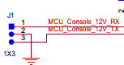
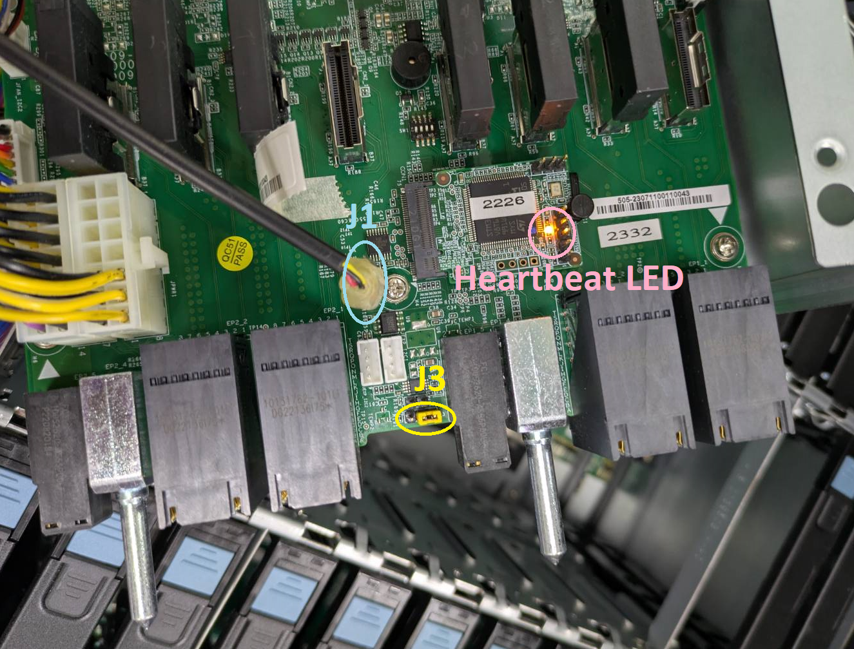

Here we use USB to UART , UART to Phone jack, 3 pin phone jack cable.
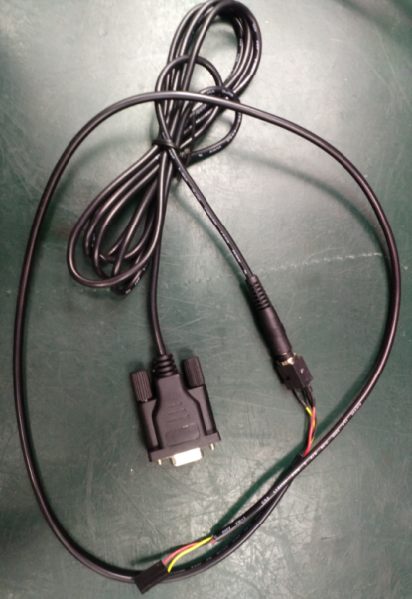
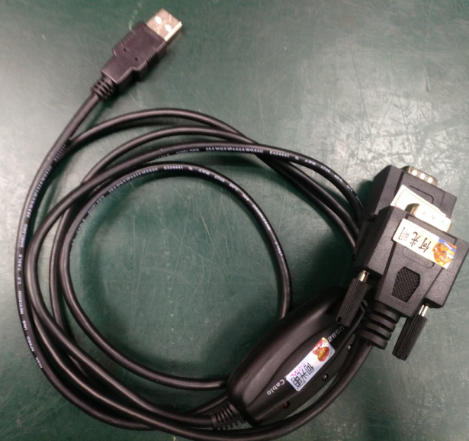
- Boot MCU into boot loader mode
- Remove AC power cord.
- Put J3 Jumper at 1-2
- Connect AC power cord.
If the MCU enter boot loader mode successfully, the heartbeat led will not toggle.
- Download ST FW update tool STM32CubeProg and install it.

- FW Update Process
- Run STM32CubeProgrammer
Click on “JLink/Fla…” and select “UART”
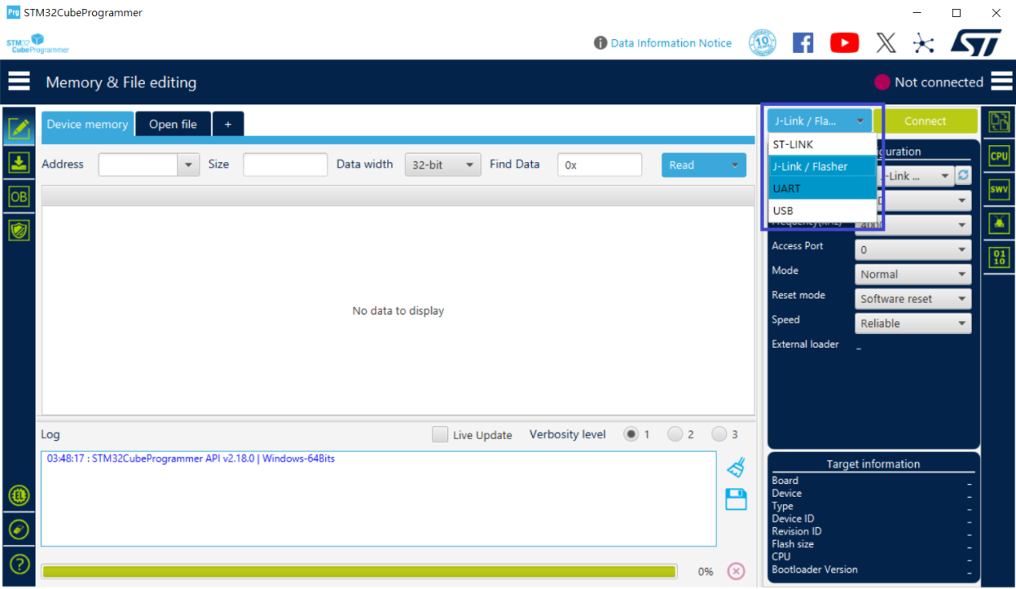

- Select The COM port which connect to the MCU UART and click “Connect”
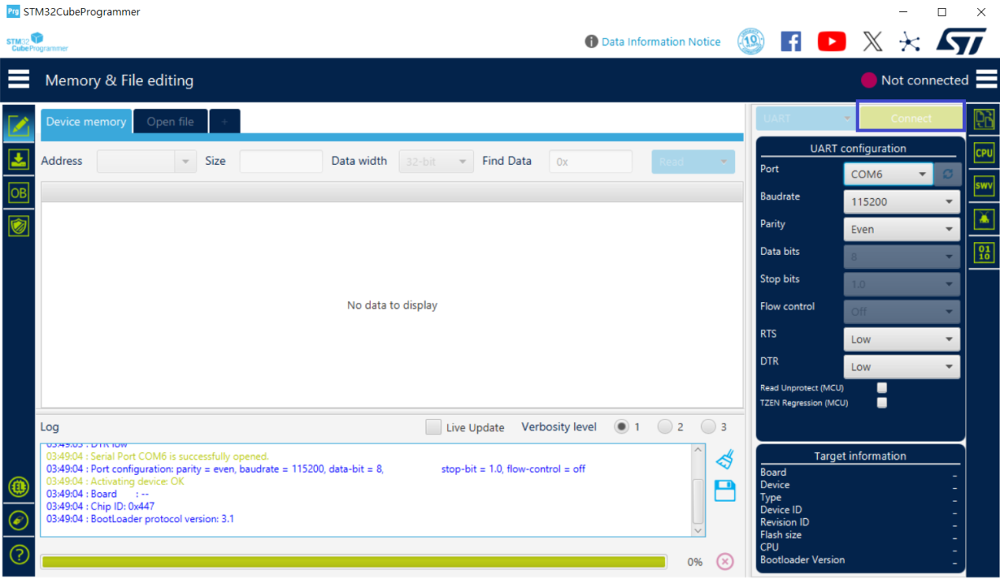
- Click On the left icon “Erasubg & programming” (Step 1)
- Press “Browse” button to select MCU FW Image (*.hex) (Step 2)
- Press “Start Programming” button. (Step 3)
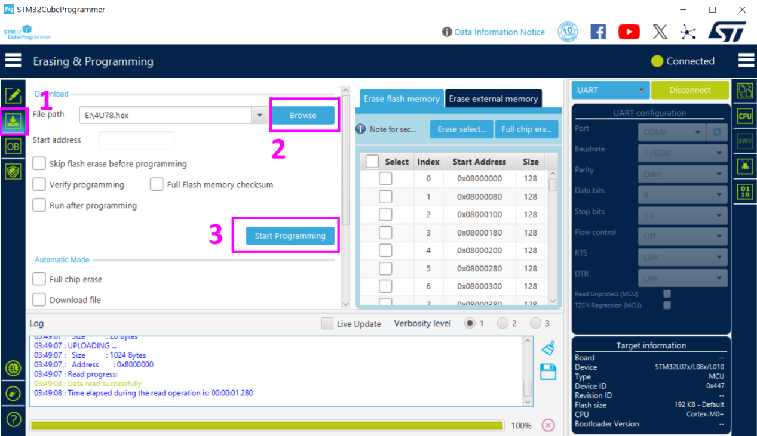
- The message “File download complete” shows and the FW update is done.
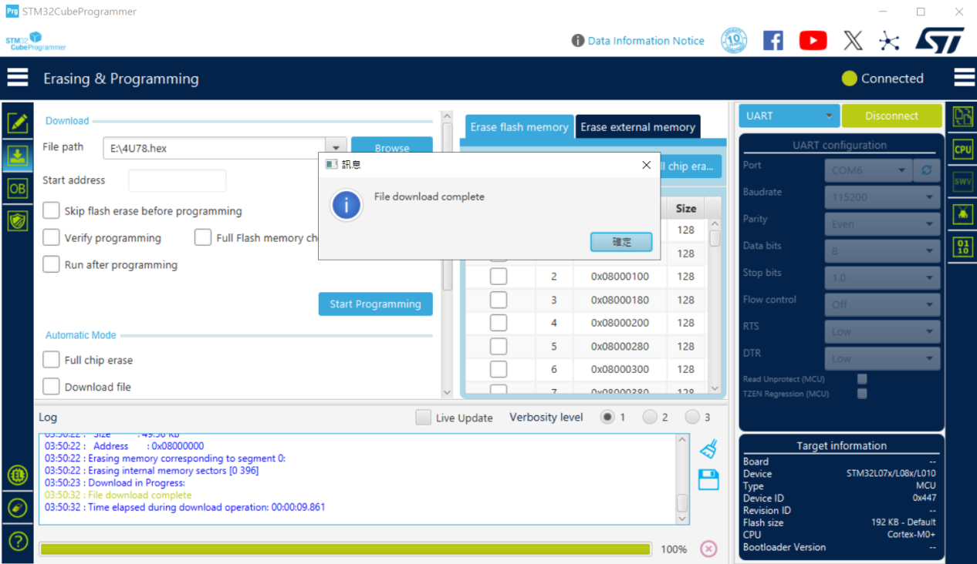
- Boot MCU into normal mode
- Remove AC power cord.
- Put J3 Jumper at 2-3
- Connect AC power cord.
If the MCU enter normal mode successfully, the heartbeat led will toggle.

- If the heartbeat led does not toggle, please
- Remove AC cord longer and re-connect
- Re-do the FW update process again.

